**ITOPS-003 – Patch Management**

The vulnerability patch scanners were configured in the infrastructure using the AWS System Manager module and its Patch Manager component. Reviewing the Compliance Report for that purpose. For operational reasons, and to avoid installing an update that could affect operational continuity, only the option of patch scan and evaluation of the same was configured, to proceed manually to its installation.

Patch Management:

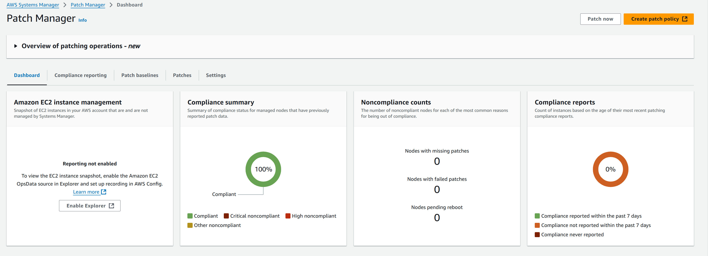

Vulnerability Scan with Amazon Inspector:

**Acknowledgment & Acceptance**

Please sign below to acknowledge that you’ve received, reviewed, and understood the security responsibilities.

**Customer Name:** ____________________  
**Signature:** _________________________  
**Date:** _____________________________